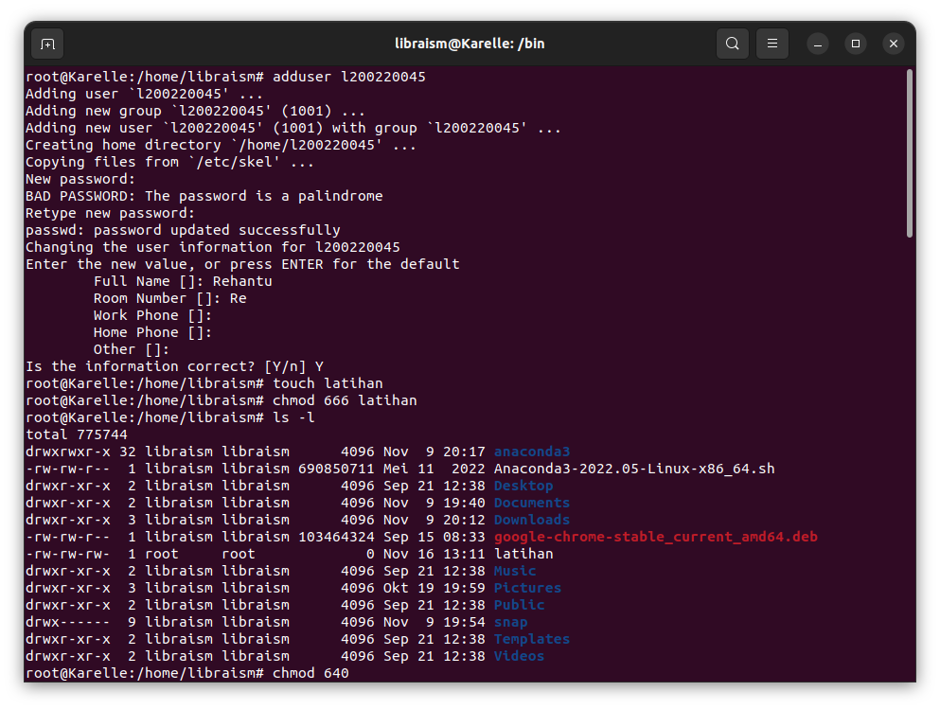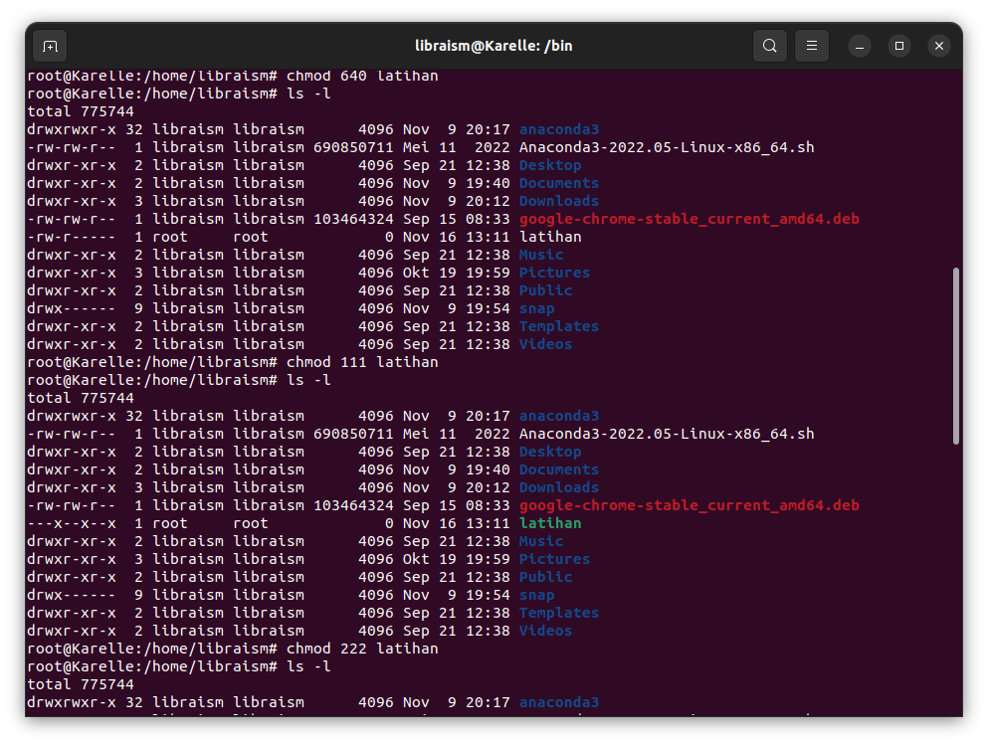

dsasasf

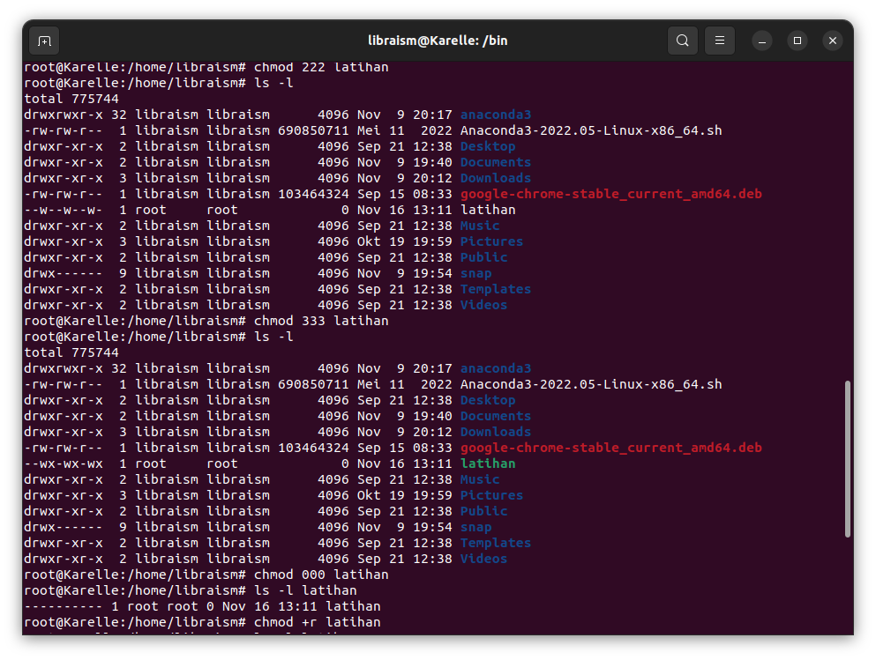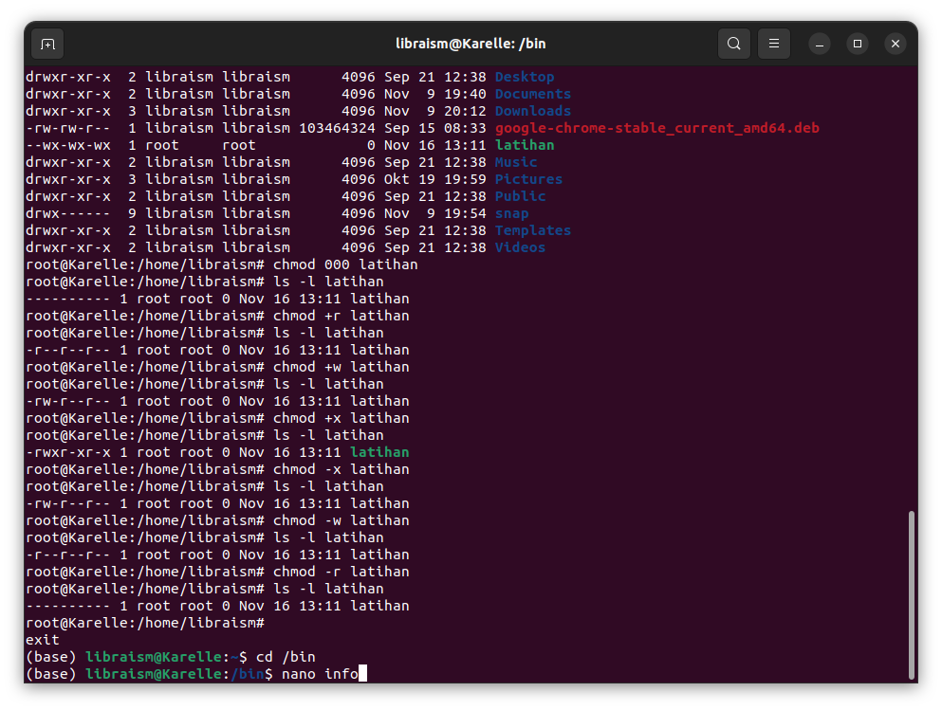

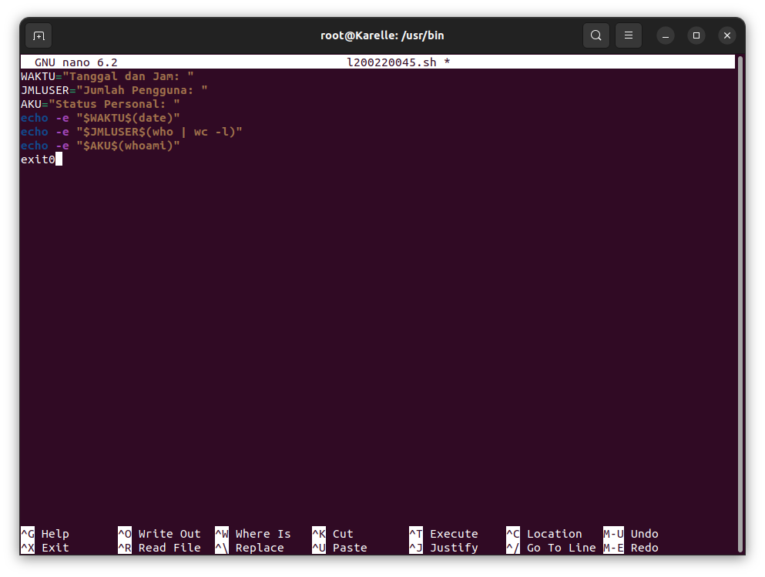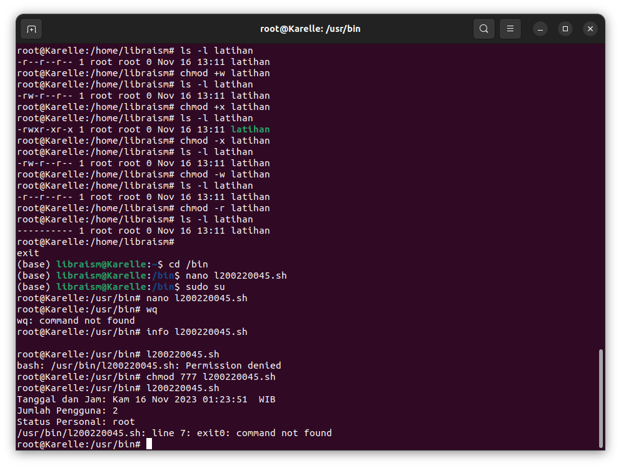

Praktikum 5

|  |  |  |  |
| --- | --- | --- | --- |
| No | User | Group | Other |
| 1 | rw- | rw- | rw- |
| 2 | rwx | rwx | r-- |
| 3 | --x | --x | -wx |
| 4 | r-- | rw- | rw- |
| 5 | rwx | --- | --- |
| 6 | --- | --- | rwx |
| 7 | --- | rw- | --- |

1. 666
2. 774
3. 113
4. 466
5. 700
6. 007
7. 060